  

**Peer Review Form**

**Reviewer's Name:**_____________________________________________ **Date:** _________________________  
  
  
**Title:**_________________________________________________________________________________________  
  
**Author(s):**_____________________________________________________________________________________

**1) Does the manuscript warrant publication in scientific journal?**  
  
_____ Acceptable in present form  
  
_____ Acceptable with minor revision, no further review necessary  
  
_____ Major revision and a second review is required  
  
_____ Not acceptable (provide detailed explanation under "comments" below)  
  
  
**2) Is the title satisfactory? If not, explain.**  
  
  
**3) Does the abstract or the executive summary adequately summarize the paper** or could it be more complete or concise? *Indicate suggested revision on the manuscript or under "comments" (below).*

**4) Have all the domains of the EUNetHTA Core Model been investigated?** Check the domains investigated

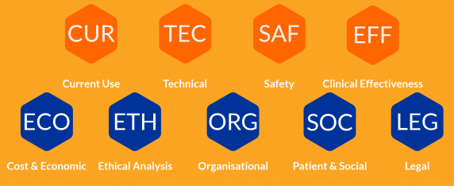

**5) Are sufficient references provided?** Are they appropriate and free from obvious omissions? If not, explain.  
  
**6) Does the paper present material effectively?** *Indicate suggested changes on manuscript or under "comments" (below).*  
  
Could the clarity or efficiency be improved by changes in the order of the paper? __________

* Should the language or grammar be improved? __________
* Are there portions of the text that could be omitted? __________

**7) Are there errors in factual information, logic, analysis, statistics, or mathematics?** __________ *Address these issues in detail in the "comments" (below). Suggest improvements.*

**8) Mechanical errors** *(address on the manuscript)*  
  
_____ Figures or tables improperly or incompletely labeled or titled or not cited  
  
_____ Misuse of references (failure to cite, reference needed and not provided)  
  
_____ Other: _______________  
  
**9) Comments** (Attach additional pages as necessary)

|  |  |  |
| --- | --- | --- |
| **Page Number** | **Line Number** | **Comment** |
|  |  |  |
|  |  |  |
|  |  |  |
|  |  |  |
|  |  |  |
|  |  |  |
|  |  |  |
|  |  |  |
|  |  |  |
|  |  |  |
|  |  |  |
|  |  |  |
|  |  |  |
|  |  |  |
|  |  |  |
|  |  |  |
|  |  |  |
|  |  |  |
|  |  |  |
|  |  |  |

**10) More tips and advice**